**REPORT**

**ON**

**SEGREGATION OF DOMESTIC SOLID WASTE IN VARIOUS COMPONENTS**

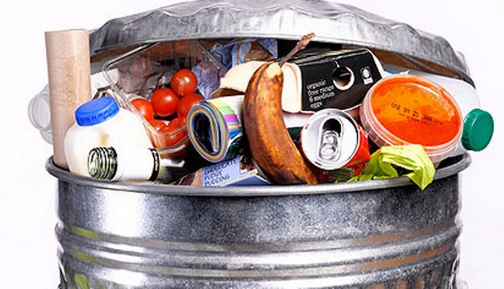

Solid waste comprising of garbage and rubbish (such as bottles, cans, clothing, compost, disposables, food packaging, food scraps, newspapers and magazines, and yard trimmings) that originates from private homes or apartments. It may also contain household hazardous waste. There are three main types of household or domestic waste. It segregate in three categories basically which are as follows:

Food and garden waste

Mixed dry recycling waste

Non recyclable waste

**Food and garden waste:**

Food waste refers to all cooked and uncooked food, including:

* fruit and vegetables
* meat, fish and bone
* plate scrapings
* rice, pasta and bread
* tea bags and coffee grounds
* used tissues or paper kitchen towels

Garden waste includes:

* grass, hedge and shrub cuttings
* leaves and weeds
* plants and flowers
* straw, hay and sawdust
* tree bark and small branches (less than 50mm or two inches in diameter)
* vegetarian pet waste (for example, from rabbits, guinea pigs and hamsters)

**Mixed dry recycling waste:**

Here is a list of mixed dry recycling materials:

Cans, including:

* food tins and drinks cans
* empty aerosol cans
* tinfoil and foil ready-meal containers (with food removed)

Cardboard, including:

* cardboard boxes
* cardboard food packets
* greeting cards
* toilet roll and kitchen roll inserts
* food and drink cartons (with liquids removed)

Paper, including:

* newspapers and magazines
* catalogues, telephone directories and paperback books
* envelopes and junk mail
* shredded paper (bagged)

Glass, including:

* glass drinks bottles (clear and coloured)
* glass food jars and bottles

Plastic, including:

* plastic bottles (emptied drinks, milk, shampoo and bleach bottles)
* yoghurt pots, plastic ready-meal containers, margarine and ice-cream tubs, plastic fruit punnets and cling film (clean with food removed)
* supermarket carrier bags

**Non-recyclable waste:**

* disposable nappies
* sanitary towels and incontinence pads (bagged)
* polystyrene packaging
* pet waste or cat litter (double-bagged)
* broken crockery (wrap first to avoid injury)
* cigarette ends and ashtray contents
* coal and wood ash (cooled)
* cotton wool pads and buds and make-up wipes
* vacuum cleaner waste
* textiles (which you can also take to a recycling bank, or request a free kerbside collection)

mentioned above is the list of different items present in solid waste generated at home and they are segregated into three major type of household categories and then they are disposed off separately as they are being managed in three different dustbins respectively which is also very important task and make dispose service much easier. These services are

* **Food and garden waste (green service)**
* **Mixed dry recycling (blue service)**
* **Non-recyclable waste (black service)**

These respective services represent wheeled bins which carry the waste and which is further disposed off. Food and garden waste is turned into compost. Mixed dry recycling waste is separated and sent to re-processers for recycling and Non-recyclable waste is incinerated to generate the electricity.